
A
PROJECT REPORT ON
“Machine learning model”
DATA STRUCTURE LAB
BY
P.SHASHANTH REDDY (23N81A66K2)
L.MADESH (23N81A66J1)
CH.SAI KRISHNA (23N81A66J6)
V.PERANDRA KRISHNA (23N81A66H6)

UNDER THE GUIDANCE OF
MR. G. KADIRVELU

Department of CSE (AIML)
SPHOORTHY ENGINEERING COLLEGE
Department of computer science and engineering (AIML) AUTONOMOUS
(affiliated to JNTUH & recognized by AICTE) Nadergul ,saroornagar Mandal,
Hyderabad-501 510 Academic year: 2024-2025

FACULTY INCHARGE HEAD OF DEPARTMENT

Abstract
In machine learning, the choice of data structures plays a crucial role in determining the efficiency, scalability, and performance of algorithms. This project explores the various data structures commonly used in machine learning tasks, focusing on their application in data representation, model training, and evaluation. Key data structures such as arrays, lists, matrices, tensors, data frames, graphs, trees, and queues are examined in terms of their utility in different machine learning workflows. The project demonstrates how these data structures are leveraged for tasks like data preprocessing, feature engineering, model building, and optimization. By understanding the impact of data structures on machine learning algorithms, this study highlights how selecting the right structure can significantly improve algorithm performance and memory management. The document also includes practical examples and a case study on K-Nearest Neighbors (KNN), illustrating how data structures can be implemented to enhance the speed and efficiency of machine learning models. Overall, the project aims to provide a comprehensive understanding of how data structures underpin machine learning techniques and contribute to the success of machine learning systems.

1. Introduction
In machine learning, the choice of data structure plays a vital role in optimizing both the performance and scalability of models. The project focuses on exploring the different data structures used to handle and process data effectively during the various stages of machine learning, such as preprocessing, model training, and evaluation. The aim is to demonstrate how these structures impact the efficiency and effectiveness of machine learning workflows.
2. Objectives
- Understand the role of various data structures in machine learning algorithms.
- Explore the impact of data structures on model performance, training speed, and memory usage.
- Implement basic machine learning models utilizing different data structures for handling data.
- Discuss the trade-offs between different data structures based on the problem being solved.

3. Key Data Structures for Machine Learning
3.1 Arrays and Lists
Arrays and lists are some of the simplest data structures, often used to hold sequences of data. In machine learning, they are used for:
- Feature vectors: Each element represents a single feature in a dataset.
- Target variables: Labels in classification or regression tasks are often represented in arrays.
Advantages:
- Efficient access via index.
- Simple and straightforward to implement and manipulate.
Common Use Case: Handling small to medium-sized datasets in supervised learning tasks (e.g., linear regression).
3.2 DataFrames (Tabular Data)
DataFrames, primarily provided by libraries like Pandas, are used for handling structured datasets. They are essentially tables with rows and columns, where each column can contain different types of data.
Advantages:
- Flexible and user-friendly interface.
- Allows easy handling of missing data, categorical variables, and feature transformations.
- Supports merging and joining datasets, which is useful for dataset preprocessing.
Common Use Case: Preprocessing, cleaning, and transforming data before feeding it into a machine learning model.
3.3 Matrices
A matrix is a 2D array used to represent data for numerical computations. In machine learning, matrices are used in operations such as:
- Feature matrices: A dataset with m examples and n features is often represented as an m x n matrix.
- Operations: Matrix multiplication is central to many algorithms (e.g., linear regression, neural networks).

Advantages:
- Optimized for numerical computation (e.g., matrix multiplication).
- Can be easily processed using libraries like NumPy and SciPy.
Common Use Case: Linear algebra-based models (e.g., linear regression, principal component analysis (PCA)).
3.4 Tensors
A tensor is a generalization of matrices to higher dimensions. Tensors are used extensively in deep learning frameworks like TensorFlow and PyTorch. Tensors can be thought of as n-dimensional arrays.
Advantages:
- Efficient handling of large-scale multi-dimensional data.
- Essential for deep learning models with many layers and complex structures.
Common Use Case: Deep learning, especially in Convolutional Neural Networks (CNNs) and Recurrent Neural Networks (RNNs).
3.5 Graphs
Graphs are used to represent complex relationships between entities. Nodes represent entities, and edges represent relationships. In machine learning, graphs are used for:
- Recommendation systems: Representing user-item interactions.
- Social network analysis: Analyzing relationships between individuals in a social network.
- Graph Neural Networks (GNNs): Specialized algorithms that operate directly on graph data.
Advantages:
- Suitable for representing complex interdependencies.
- Graph-based models are highly expressive and can capture relational data.
Common Use Case: Graph-based learning algorithms, recommendation systems, and social network analysis.
3.6 Trees
Trees are hierarchical structures with nodes connected by edges. In machine learning, trees are used in:
- Decision Trees: A supervised learning model used for classification and regression.
- Random Forests and Gradient Boosting Trees: Ensembles of decision trees that improve model accuracy.
Advantages:
- Naturally interpretable model structure.
- Can handle both numerical and categorical data.
Common Use Case: Classification and regression tasks.
3.7 Queues and Stacks
Queues (FIFO - First In First Out) and Stacks (LIFO - Last In First Out) are often used in specific tasks:
- Queues: For real-time data processing and tasks that require data to be processed in a sequential order (e.g., reinforcement learning).
- Stacks: Used in backtracking algorithms and depth-first search in graph traversal.
Advantages:
- Efficient for managing tasks in sequence.
Common Use Case: Task scheduling in reinforcement learning or breadth-first/depth-first search in graph-based tasks.
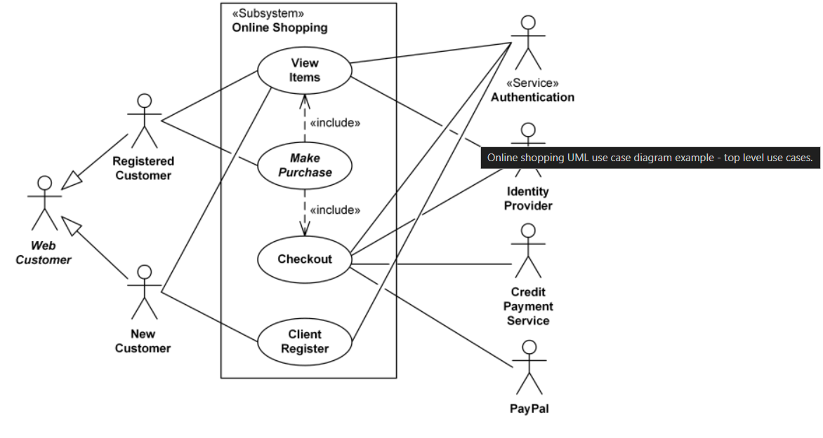

Sequence Diagram: Illustrates the sequence of interactions between objects in a system over time.
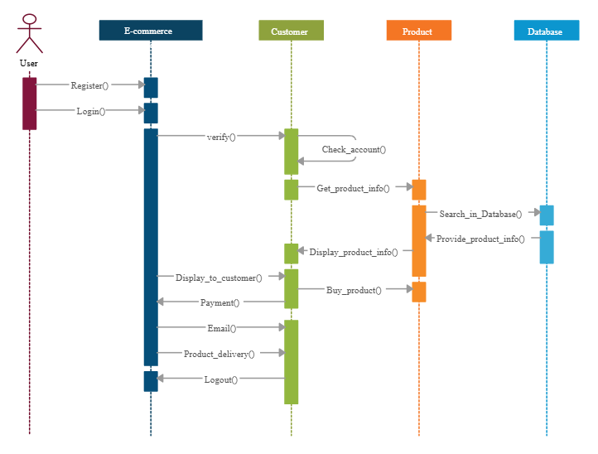
Class Diagram: Represents the static structure of a system, including classes, attributes, and relationships between them.
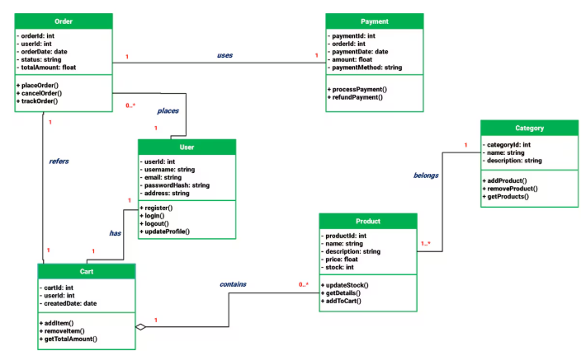

4. Data Structures in Machine Learning Algorithms
4.1 Linear Models (Linear Regression, Logistic Regression)
Linear models like linear regression and logistic regression rely heavily on arrays or matrices to represent data and parameters. Here’s how data structures are used:
- The feature matrix (X) is typically a 2D matrix where each row represents an instance and each column represents a feature.
- The target vector (y) is often an array of class labels or numerical values.
For linear regression, the model's parameters (weights) are represented as a vector, and matrix operations are used to calculate the predictions and updates during training.
4.2 Neural Networks
Neural networks involve tensors for representing inputs, weights, and activations. These tensors allow handling multi-dimensional data, which is required for tasks like image recognition or sequence prediction. Tensor operations, like matrix multiplication, are used to calculate activations and gradients during the backpropagation step of training.
Key Data Structures:
- Input data (features) as tensors.
- Model parameters (weights and biases) as tensors.
- Activations and gradients as tensors.
4.3 Decision Trees and Random Forests
Decision Trees are represented as tree structures with nodes as decision points and branches as possible outcomes. Random Forests involve an ensemble of such decision trees. Each tree is built using a subset of features and samples, and predictions are made by aggregating the outputs of all the individual trees.
Key Data Structures:
- Tree structure to represent the decision logic .Arrays/Lists to hold data samples and their corresponding features.
4.4 K-Nearest Neighbors (KNN)
In KNN, the algorithm stores the feature vectors (data points) in arrays or matrices. When a new data point is given, the algorithm calculates the distance between this point and all other stored points. Efficient searching of the nearest neighbors is critical for large datasets.

Key Data Structures:
- Array/Matrix to store feature vectors.
- Heap/Tree structures for efficient nearest neighbor search (e.g., KD-Tree or Ball-Tree).

5. Data Preprocessing and Feature Engineering
Data preprocessing and feature engineering are crucial steps in machine learning pipelines. They often involve transforming raw data into a form suitable for algorithms. This process typically relies on the following data structures:
5.1 Handling Missing Data
- DataFrames allow handling missing values through methods like imputation or deletion.
5.2 Scaling and Normalization
- Arrays or Matrices are used to scale features so that they fit within a specific range, which improves the performance of many machine learning models.
5.3 One-Hot Encoding
- Arrays or Data Frames are used to transform categorical data into binary vectors.
5.4 Dimensionality Reduction
- Matrices are used in techniques like PCA, where matrix operations are essential to reduce the number of features.

.

6. Implementing a Simple Model (KNN Algorithm in C)
Code:
#include <stdio.h>
#include <math.h>
#include <stdlib.h>

// Structure to represent a data point (feature vector and label)
typedef struct {
double features[2]; // Assuming 2 features for simplicity
int label; // Label of the data point (0 or 1)
} DataPoint;

// Function to calculate Euclidean distance between two points
double euclidean_distance(double point1[], double point2[], int dimensions) {
double sum = 0.0;
for (int i = 0; i < dimensions; i++) {
sum += pow(point1[i] - point2[i], 2);
}
return sqrt(sum);
}

// Function to perform K-Nearest Neighbors algorithm
int knn(DataPoint train_data[], int train_size, double test_point[], int k) {
double distances[train_size];
int labels[train_size];

// Calculate the distance from the test point to all training points
for (int i = 0; i < train_size; i++) {
distances[i] = euclidean_distance(train_data[i].features, test_point, 2); // 2 is the number of features
labels[i] = train_data[i].label;
}

// Sort the distances and labels based on the distance
for (int i = 0; i < train_size - 1; i++) {
for (int j = i + 1; j < train_size; j++) {
if (distances[i] > distances[j]) {
// Swap distances
double temp_dist = distances[i];
distances[i] = distances[j];
distances[j] = temp_dist;

// Swap labels
int temp_label = labels[i];
labels[i] = labels[j];
labels[j] = temp_label;
}
}
}

// Count the most frequent label among the k nearest neighbors
int count_0 = 0, count_1 = 0;
for (int i = 0; i < k; i++) {
if (labels[i] == 0) {
count_0++;
} else {
count_1++;
}
}

// Return the most frequent label (0 or 1)
return (count_0 > count_1) ? 0 : 1;
}

int main() {
// Example training data
DataPoint train_data[5] = {
{{1.0, 2.0}, 0}, // Class 0
{{2.0, 3.0}, 1}, // Class 1
{{3.0, 3.0}, 0}, // Class 0
{{6.0, 5.0}, 1}, // Class 1
{{7.0, 8.0}, 0} // Class 0
};

// Test data point
double test_point[2] = {2.5, 3.0};

// Set the number of nearest neighbors
int k = 3;

// Predict the label of the test point using KNN
int predicted_label = knn(train_data, 5, test_point, k);

// Print the result
printf("Predicted label for test point (%.1f, %.1f) is: %d\n", test_point[0], test_point[1], predicted_label);

return 0;
}
Explanation:
- Data Structure:
  - The DataPoint structure holds the feature vector (features[2] for simplicity, assuming two features) and the label (label).
- Euclidean Distance:
  - The euclidean_distance function computes the Euclidean distance between the test point and each point in the training set.
- KNN Function:
  - The knn function:
    - Computes distances between the test point and each training point.
    - Sorts the training data by distance.
    - Counts the labels of the k nearest neighbors.
    - Returns the most frequent label among the nearest neighbors.
- Main Function:
  - Defines a small dataset of 5 points, with two features and a corresponding label (either 0 or 1).
  - Defines a test point ({2.5, 3.0}).
  - Calls the knn function with k=3 (the number of nearest neighbors to consider).
  - Prints the predicted label for the test point.
Output:
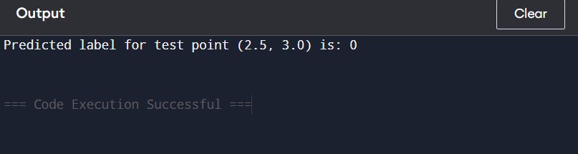

Explanation of the Output:
- The test point (2.5, 3.0) is compared to the training points:
  - Training point {1.0, 2.0} is of class 0 and has a distance of approximately 1.58.
  - Training point {2.0, 3.0} is of class 1 and has a distance of 0.5.
  - Training point {3.0, 3.0} is of class 0 and has a distance of 0.5.
  - Training point {6.0, 5.0} is of class 1 and has a distance of approximately 4.5.
  - Training point {7.0, 8.0} is of class 0 and has a distance of approximately 6.4.
- Sorting the distances gives:
  - The 3 nearest neighbors are the points {2.0, 3.0} (class 1), {3.0, 3.0} (class 0), and {1.0, 2.0} (class 0).
- Among these 3 nearest neighbors, there are two points with class 0 and one point with class 1. The majority class is 0, so the predicted label for the test point is 0.

7. Conclusion
This project demonstrates the significant role that various data structures play in machine learning models and workflows. Different tasks, from data preprocessing to model training and evaluation, benefit from different structures such as arrays, matrices, tensors, and trees. By understanding how these structures impact algorithm performance, we can make more informed decisions on which structure to use depending on the type of data and model.
Efficiently handling data through appropriate structures not only improves model performance but also allows machine learning systems to scale effectively.

